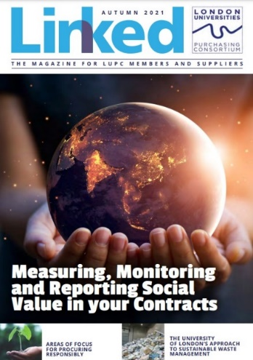
Advertising in LUPC’s digital Linked Magazine
To cover the costs of producing a quarterly edition of LUPC’s Linked magazine, we offer LUPC approved suppliers the opportunity to advertise.

Benefits

- Our circulation includes more than 300 individual buyers at more than 80 member institutions, plus all of LUPC’s suppliers.
- The magazine is also available to anyone who accesses the LUPC website, including back issues.
- Your support demonstrates to customers your commitment to LUPC agreements.

Advertisement Rates

  - £175 +VAT for quarter page
  - £300 +VAT for half page
  - £500 + VAT for full page

10% discount available for booking 4 consecutive spaces in advance

Invoices are sent one month in advance of publication and payment is due 30 days past invoice date.

Please note, if you are no longer an approved supplier to LUPC Members at the date of publication, we cannot publish your advert and we will refund your payment.

Guidelines

- Advertisement and editorial submissions are granted strictly on a first come, first serve basis.
- Deadlines must be strictly adhered to.
- Artwork guidelines must be followed.
- Suppliers may not specifically promote goods and services that are outside the scope of your agreement with LUPC – promoting products covered by the agreement and/or a general company advert (making reference to the agreement) is fine.
- Please include a document with the hyperlinks you want featured on your artwork and limit these to a max of 4 links per artwork.
- All adverts must include:
- Supplier contact details (a hyperlink to your website or an email address etc)
- Reference should be made to the framework agreement and reference number in your advert
- The standard term for approved suppliers is ‘LUPC framework supplier’, not ‘Preferred supplier’ or ‘Number 1 Supplier’.

Artwork specification

  - Supply artwork as a high resolution pdf to Giorgia Varriale

  - Advert bleed to be 3mm
  - Images to be high res and colour, min. 300dpi

  - Please ensure fonts are embedded in adverts when the PDF is created

Copy Area :

♦ Full page 210mm (horizontal) x 297mm (vertical)
♦ Half page 210mm (horizontal) x 148mm (vertical)
♦ Quarter page 105mm (horizontal) x 148mm (vertical)

Contacts and booking

To book your advert, you must sign the authorisation form on page 3 and return this to Giorgia Varriale.

For queries about bookings, please contact Giorgia Varriale, 020 7307 2771.

Editorial Submissions

We also welcome articles from suppliers about current issues/updates in your commodity markets, case studies, best practice, sustainability etc. There is no charge for placing these articles, but they must focus on the ‘big issues’, rather than being an overt ‘sell’ for a particular supplier.

Please be aware, our free supplier editorials are not advertorials – each article from a supplier must focus on the ‘bigger picture’ ie – case studies (especially including LUPC members), new legislation, best practice, hints and tips from your industry etc. It should not be used to promote off-contract goods/services and it shouldn’t be an overt sell for your company or its specific products (for this, you’ll need to buy advertising from us). To be fair to other suppliers we will edit this if it veers off the wrong path – if unsure, please have a read through some of our back issues, which include supplier- written editorials and hit the right tone https://www.lupc.ac.uk/news-events/linked-magazine/.
Of course, we’ll by- line this article to you and include your logo and contact details, so there are definitely benefits!

For more information contact Giorgia Varriale, 020 7307 2771 in the first instance with a short overview of your topic, so we can confirm space is available in a future issue and that this doesn’t duplicate another article. On approval, all articles would need to be 650 words.

Schedule

Winter 2022/23 (published January)
Artwork deadline: Friday 9 December 2022

Spring 2023 (published April)
Artwork deadline: Friday 24 March 2023

Summer 2023 (published July)
Artwork deadline: Friday 23 June 2023
Autumn 2023 (published October)
Artwork deadline: Friday 22 September 2023

Linked Advertising Authorisation Form

Company Name:

Name:

Email:

Tel:

Purchase Order Number (if applicable): Invoice Address:

Which issue? (Dates of publication in brackets)

Summer 2022 (July) Winter ‘22/23 (January)

Autumn 2022 (October) Spring 23 (April)

Size of advert:

Quarter page Half page Full page
£175 +VAT £300 + VAT £500 + VAT

**10% discount available for booking 4 consecutive spaces in advance**

Please state if half page advert will be horizontal or vertical in orientation:

Payment Terms. This booking form commits you to paying for the specified advertising within 30 days of the invoice date. A refund will only be provided if you give 21 days or more notice of cancellation to LUPC before the advert artwork deadline.

Signature and date

Email completed form to: Giorgia Varriale

